**Automated Car Parking System Database Design**

1.Description :

An automated car parking system is designed to efficiently manage parking lots by utilizing advanced technologies. This system optimizes space utilization and provides a seamless experience for both vehicle owners and administrators. Key tables include parking_Location for diverse locations, parking_space for different spaces, and parking_space_slot linking spaces and slots. The vehicle table stores vehicle details, while the parking_slot_allocation table tracks slot allocations. User accounts are managed by the User table, and payment transactions are recorded in the payment table.

2. Entity-Relationship Diagram :

Automated Car Parking System

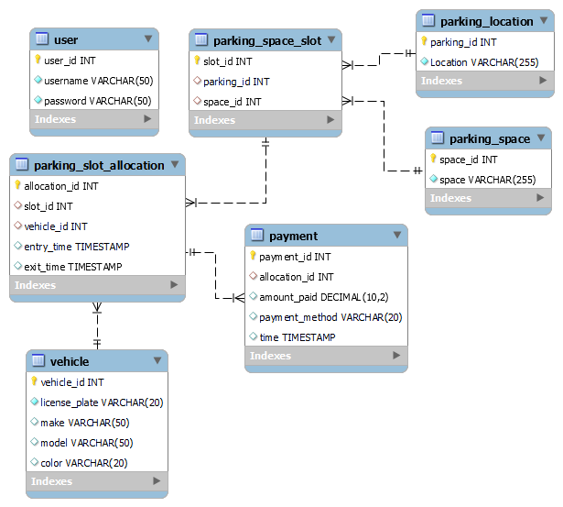

3. Table Details:

### **parking_Location**

Stores information about different parking locations.

| **Field** | **Datatype** | **Constraint** |
| --- | --- | --- |
| parking_id | INT | Primary Key |
| Location | VARCHAR | NOT NULL |

### **parking_space**

Records information about different parking spaces within a location.

| **Field** | **Datatype** | **Constraint** |
| --- | --- | --- |
| space_id | INT | Primary Key |
| space | VARCHAR | NOT NULL |

### **parking_space_slot**

Manages the association between parking spaces and slots within a location.

| **Field** | **Datatype** | **Constraint** |
| --- | --- | --- |
| slot_id | INT | Primary Key |
| parking_id | INT | Foreign Key (references parking_Location.parking_id) |
| space_id | INT | Foreign Key (references parking_space.space_id) |

### **vehicle**

Stores information about vehicles that use the parking facility.

| **Field** | **Datatype** | **Constraint** |
| --- | --- | --- |
| vehicle_id | INT | Primary Key |
| license_plate | VARCHAR | NOT NULL |
| make | VARCHAR |  |
| model | VARCHAR |  |
| color | VARCHAR |  |

### **parking_slot_allocation**

Tracks the allocation of parking slots to vehicles.

| **Field** | **Datatype** | **Constraint** |
| --- | --- | --- |
| allocation_id | INT | Primary Key |
| slot_id | INT | Foreign Key (references parking_space_slot.slot_id) |
| vehicle_id | INT | Foreign Key (references vehicle.vehicle_id) |
| entry_time | TIMESTAMP |  |
| exit_time | TIMESTAMP |  |

### **User**

Manages user accounts for accessing the system.

| **Field** | **Datatype** | **Constraint** |
| --- | --- | --- |
| user_id | INT | Primary Key |
| username | VARCHAR | NOT NULL |
| password | VARCHAR | NOT NULL |

### **payment**

Records payment transactions for parking.

| **Field** | **Datatype** | **Constraint** |
| --- | --- | --- |
| payment_id | INT | Primary Key |
| allocation_id | INT | Foreign Key (references parking_slot_allocation.allocation_id) |
| amount_paid | DECIMAL |  |
| payment_method | VARCHAR |  |
| time | TIMESTAMP |  |